SUCCESS STORIES OF SUPPORT DURING THE MOBILE COURT
1st Story
STEWARDWOMEN was delighted to be part of the Bentiu Mobile court that was able to convict 5 perpetrators for rape, bringing perpetrators to book is part of our drive as we protect women and girls against GBV and, any other forms of violence against women, here are some landmark rulings that were decided by the Bentiu Mobile High Court where two men were concurrently sentenced to 10 years each for raping a 16 year old girl, This judgment is to strongly deter others from perpetrating against women and girls in South Sudan and to serve as an example to the entire universe.
We were introduced a 30-year-old woman by the name Nyapuok Kuol whose case was made aware to us by the UNMISS team as she was often serving tea to the mobile court team, but sadly on this day her jovial laughter and warm embrace was no more as she was badly beaten by her husband and chased out of their home, we immediately rushed her to a safe place with her children and supported her to get medical care for the bruises she sustained. STEWARDWOMEN was able to support her with with meals and accommodation as police officers carried on further investigations into the matter, she was shy and reserved but from our continuous conversations she felt safe to tell her story.
Here is an excerpt of the INTERVIEW follow up.
Drusilla: Good afternoon , how are you ?
Nyapuok: am fine
Drusilla: So tell me how have you been since we last met a few days ago
Nyapuok: I have been able to reconsider going back to my business to continue supporting my children as am the sole bread winner , am also happy that am at peace now as my husband is in prison and will not cause me any more harm.
Drusilla: Wow that is a good development am so proud of you and I encourage you to go for it and we are glad that you are now safe
Nyapuok: thank you
Drusilla: today I wanted to hear from you on how the support you got from STEWARDWOMEN has impacted your life
Nyapuok: I am really grateful and thankful to STEWARDWOMEN they were there in my time of need and all through my journey till the perpetrator has been arrested, I remember that day I was in so much pain and stressed, but after getting food and a place to sleep for the night I felt some sense of peace and calm, I was safe with my children and I didn’t have to worry
Drusilla: am glad to hear of the impact the support from STEWARDWOMEN had on your life and that you were able to find justice and peace amidst all
Nyapuok: Thank you for what you are doing to help women and girls, in our society here women don’t have voices to stand up for themselves, that’s why I kept quiet when my husband was beating me but after what happened to me am now able to stand up for myself, I have not only benefitted from the meals and accommodation but also from the psychosocial support which has positively impacted my health. Thank you
Drusilla: Thank you and as STEWARDWOMEN, it’s a pleasure to have supported you.
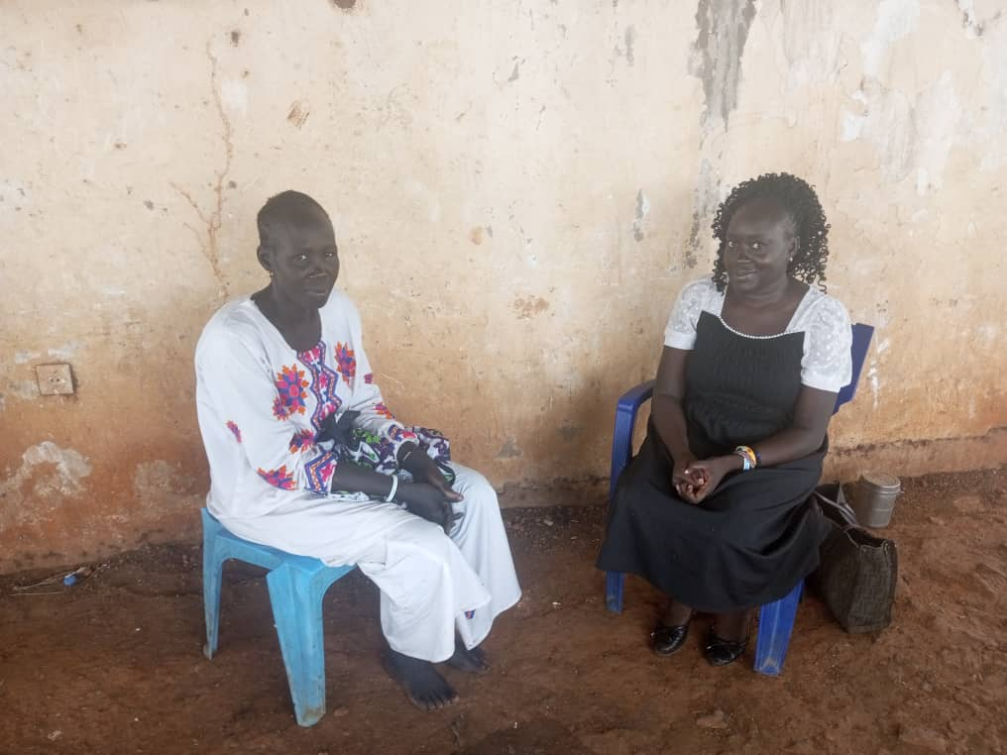
STEWARDWOMEN Legal Aid Officer/Field Manager-Bentiu (Ms.Drusilla Kore) and the

2nd Story
Survivor (Ms.Nyapuok Kuol) during the Bentiu mobile court.
We are introduced to a young woman by the name of Maria Nyaruai all the way from POC which is approximately 15KM away from Bentiu Town where the mobile court was taking place. She was in court trying to get back her biological children that were taken by her divorced husband who is not the biological father of the children, she has been fighting this case in the customary courts but has not been successful thus this was her last hope to reclaim custody of her children. She benefitted from the transport support from STEWARDWOMEN for the duration of her case until she was able to get justice something that gave her a sigh of relief for achieving something that had seemed impossible due to lacks of means of transport for getting to the court.
Here is an excerpt from the interview,
Drusilla: Good morning, nice to meet you again? how have you been?
Maria: I have been well
Drusilla: tell me how you feel now that your case was concluded and the decision of the court was in your favor
Maria: I am very happy and excited honestly I never thought this would happen ,am still in shock and processing everything that happened
Drusilla: am glad to hear that and I also wanted to know how did the support that STEWARDWOMEN give you impact you?
Maria: the support really helped me to come and present my case before the court and be able to get justice and for that am grateful to STEWARDWOMEN for the transport that enabled me to achieve this
Drusilla: am glad that STEWARDWOMEN was able to impact your life for good and thank you for your time.
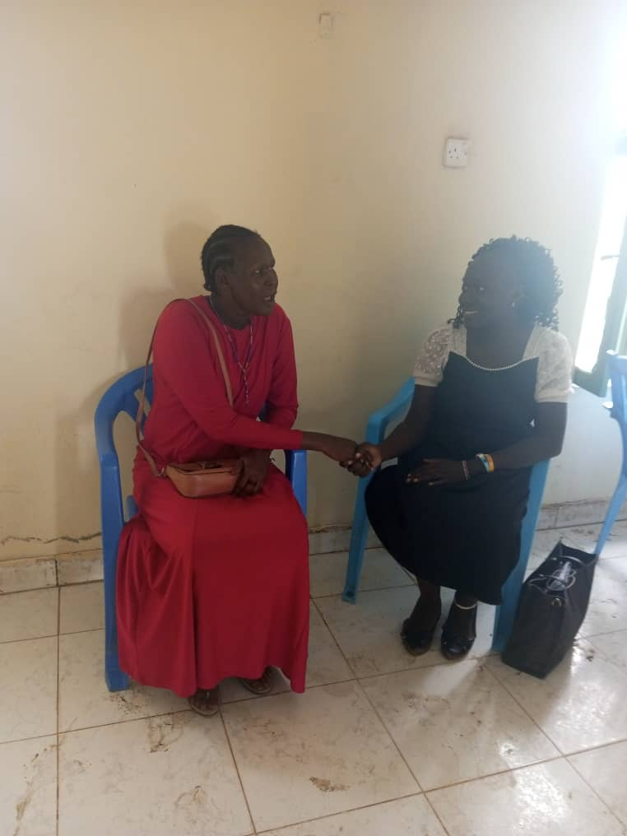
From the right STEWARDWOMEN Legal Aid Officer/Field Manager-Bentiu(Ms.Drusilla), Bentiu Mobile Court support beneficiary(Ms. Maria)
STEWARDWOMEN was able to support close to 26 survivors and witnesses both men and women during the Bentiu Mobile Court, the above just highlights stories of a few that we were able to get a chance to speak with after their cases since most of them went back to their villages immediately after their hearings and others immediately after a solution and other cases were still pending further investigations, STEWARDWOMEN was on ground handling survivors immediately they came to police station looking for help, but all had gratitude in their hearts for the support they got during their cases from the beginning to its completion, and for those whose the court decisions was in their favor expressed even more happiness believing that we were their guardian angels in time of need, most noted that this mobile courts can come like this but if someone doesn’t have the resources to facilitate them they miss out on justice and were happy we were able to bridge that gap.

