SUCCESS STORY
STEWARDWOMEN under the UNTF project aims to scale up lifesaving GBV prevention and response through provision of legal aid services and livelihood assistance to GBV survivors. The project under the UNTF entitled ‘Strengthening Provision and Co-ordination of services to Survivors of rape and early/child marriage’, Bakhita Nyaluong Tong got livelihood assistance and save money from her businesses and also provide basic needs for her family. Being a survivor of rape, she was able to join TETHLOI women savings and loans group which was formed by STEWARDWOMEN and supported with livelihood assistance including provision of start-up kits for tea selling business and bed sheet embroidery business.

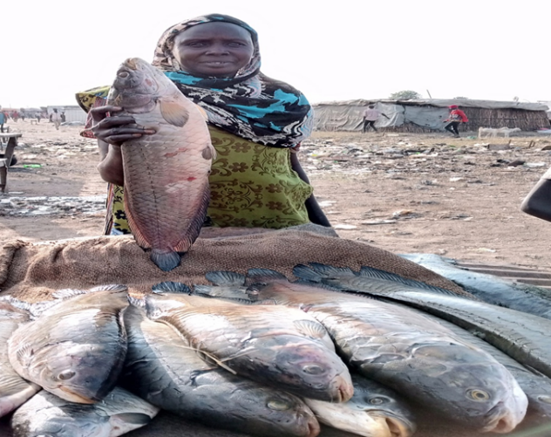

Photograph of Bakhita at her fish selling joint in Rubkona Market

Am Bakhita Nyaluong Tong, 42 year old mother of 5 children and from Matar 1 village in Rubkona County, Unity State, she believes in giving a woman an opportunity to be able to work and become economically self-reliant instead of relying on the husband.
Bakhita was a victim of GBV and in particular, domestic violence. Occasionally, her husband beat her up because she is to provide food for the family. She have to look after her abusive husband and children and provide food on the table which was causing her psychological torture and trauma. She was forced to sell milk which she get from the cattle camp and sell at Rubkona Town in order to support her family as the husband was not working due to old age. She would trek every single day from Matar 1 village in Rubkona up to the cattle camp near Guit junction, in order to buy milk for sell every day. The husband expected her to provide for the family and when there was no food, he [Husband] would beat her up. Her husband never allowed her to go to work because of insecurity and when she leaves the house, in the evening for market he would beat her up when she returns. She [Bakhita] needed a sustainable income generating activity to provide for the family and ways to prevent the physical abuse from happening to her. STEWARDWOMEN has helped Bakhita to receive psychosocial support as being a member of TETHLOI women saving and loans group and also save with the group because at the end she interacts weekly with fellow women to discuss the challenges facing them and come up with solutions together with caseworker [STW]. Bahkita now started her own separate business of selling fresh fish in Rubkona market which makes her get additional money. There is peace in her family because of the effort of STW and that is why she considers “CHANGE” as the most important thing unlike before. There are no more cases of domestic violence at her home since she is the bread winner of the family. Through the intervention of STEWARDWOMEN in Rubkona County, a total of 50 women have benefitted from livelihood assistance and are able to provide for their family as well as save money for future use.

