Expression and the excitement for the justice of her three daughters.
SUCCESS STORYOF ONE OF THE SURVI VORS’ FATHER
‘’Through the JCC initiative by STEWARDWOMEN, to protect and uphold the rights of women and girls and promoting justice, I am now seeing justice coming. My daughters are saying the lights of justice that they longed for since the incident happened and reported in 2022’’ stated by Eluzai the father of the survivors.
Mr Eluzai says adds that, ‘’since then when I opened rape charges against perpetrators who had carnal knowledge with his daughters (minors), nothing much was done in the name of a devil known as corruption, the investigation process was interrupted to the extent that even police alleged to have lost the file amidst all my struggles.
My hopes are now vested in the JCC, I have shared my grievances with the legal Aid attorney and as I speak, he reached out the public prosecution attorney of Raja who is based in Wau where a new file was opened containing the charges of rape, the perpetrators were arrested and remanded awaiting mobile court and the police investigating officer that did the first investigation was subjected to disciplinary action and barred from carrying out any further investigations. My daughters have testified having beautify nights but also feeling secure knowing that their tormentor is locked up and nothing strange can happen to them.
Eluzai, shared the level of traumatization him and his daughters went through in pursuing justice for her three daughters since the case happened he says. ‘’ without money is very hard for people like me who are financially constraint to get justice, justice is for those who have money and may be those that are armed’’.
In his final remarks, Eluzai confirms that ‘’pursuing justices in this country requires high level of patience and commitment and as a single parent to my girls I will do everything possible to protect my daughters, their rights will be defended. My special gratitude goes to STEWARDWOMEN for the initiative of the JCC that offers free legal aid to the vulnerable. My daughters expressed their excitement hearing that their tormentor is remanded and they look forward for his sentence once the matter is handled through the mobile court deployment’’.
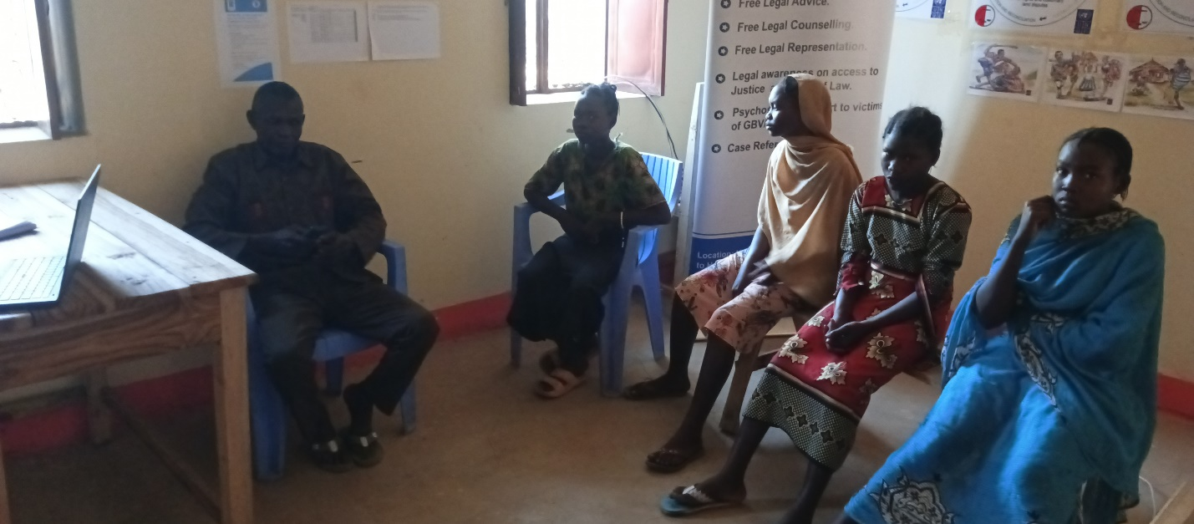
Photo taken at the JCC after the survivor’s father expressed his gratitude for the Justice process so far taken by STEWARDWOMEN in upholding the rights of her daughter.

THE MENTLE HEALING JOURNEY OF ZAINAB
Zainab one of the beneficiaries of Psychosocial Support intervention provided by STEWARDWOMEN under JCC. After experiencing sexual gender-based violence, Zainab received counselling, therapy and life skills, which have enabled her to be an advocate for peaceful families.
Zainab was forced by her uncle to marry a man that was three times her age. Having lost both her parents when she was a toddler, Zainab was raised by her uncle, who seized the earliest opportunity to marry her off.
“I was not ready for marriage. My uncle married me off without my consent. My husband forced me into sexual acts and whenever I objected, he beat me up leaving me in great pain. Sometimes, I resorted to sleeping outside of our home for fear of being sexually and physically harassed. The marriage left me without peace, and I was experiencing mental distress, hopelessness and isolation” Zainab sadly recounted her experience.
“Before I received psychosocial support, I was always angry, withdrawn, and uncertain of the next day. In September 2024, I shared with my neighbour the emotional and mental health challenges I was experiencing, and she introduced me to the STEWARDWOMEN, Psychosocial Organization which also defends the rights of women and girls” Zainab said.
“In less than three days I was given an appointment date where I was given a platform to share my distress without being judged, which gave me hope that I would finally recover from the mental health challenges I was experiencing. Today, I am a happy woman, able to take care of myself” said by Zainab excited about the transformation in her life.
Zainab is now a change agent in her community, passionate about building peaceful and happy families. By the end of 2024, Zainab had supported three families with counselling services.

