My name is Gloria, a road side tea seller 29 years old and a mother of 3 children living in Munuki block A,
I started tea business in 2019 to feed my family since my husband is a solider and they do not receive salary on monthly basis but the business do not help me because most part of the money is used for paying house rent at the end of month and nothing is saved.
Then in 2020 I joined salama Mary go around group to start savings but still I have low savings from my business .In Sept 2021 STW came to our group started mentoring us and in October they organized two training on business management and Financial literacy of which I attended it has open my understanding of business and immediately I include Chapatti and Samboza(three Corner) in tea business which has boosted my business and now I can save 3000ssp ($8) daily and I made recording keeping as must to evaluate my business.
Thanks to STW and UNWOMEN for opening my eye and I can take care of my family.

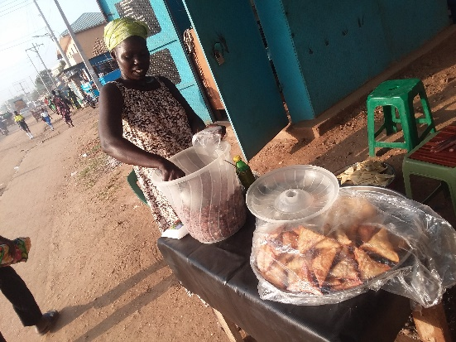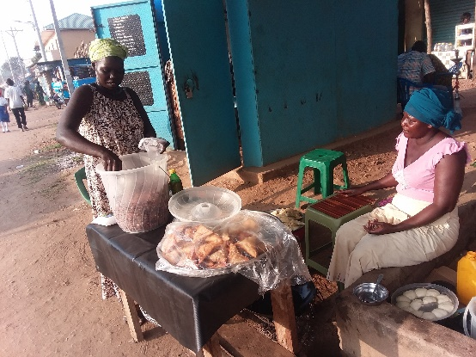
Figure 3Mrs. Gloria serving her customer as Narrate her Story to Izaru James Staff of STW on 15th Nov.2021

